DESIGN AND ANALYSIS OF ALGORITHM

TEAM MEMBERS:

22k-4333: Alishba Hassan

22k-4617: Nimil Zubair

22k-4526: Waniya Badar

Question No:1

A :

Part 1:

def Find_min_max(Array,low,high):

  if(low==high):

    return(Array[low],Array[low])

  if((high-low)==1):

    if(Array[low]<Array[high]):

      return (Array[low],Array[high])

    else:

      return(Array[high],Array[low])

  mid=(low+high)//2

  min1,max1=Find_min_max(Array,low,mid)

  min2,max2=Find_min_max(Array,mid+1,high)

  min_value=min(min1,min2)

  max_value=max(max1,max2)

  return(min_value,max_value)

n=int(input("Enter Number of Elements in an Array : "))

A=[]

for i in range (n):

  element=int(input(f"Number {i+1}: "))

  A.append(element)

print("Array: ",A)

Min,Max=Find_min_max(A,0,len(A)-1)

print(f"Minimum Value is :{Min}, Maximum Value is : {Max}")

Example Output:

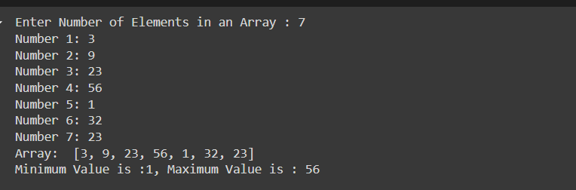

Part 2:

* Defining Recurrence Relation:

1. Recursive Comparison: Function call itself twice for each half of the array that requires time complexity: T(n/2).
2. Additional Comparison: There are two additional comparisons to find minimum and maximum value .One comparison to find minimum value between min1 and min2Other comparison to find maximum value between max1 and max2.

Hence Recurrence relation is:

T(n)=2T(n/2)+2

Base case: T(2)=1,as only one comparison will be performed.

* Solving Recurrence Relation:

T(n)=2T(n/2)+2 ---(i)

T(n/2)=2T(n/4)+2 ---(ii)

T(n/4)=2T(n/4)+2 ---(iii)

Substituting eq (ii) in eq (i):

T(n)=2(2T(n/4)+2)+2

T(n)=4T(n/4)+4+2 ---(iv)

Substituting eq (iii) in eq (iv):

T(n)=4(2T(n/8)+2)+4+2

T(n)=8T(n/8)+8+4+2

T(n)=2kT(n/2k )+2(2k-1)

Since 2k =T(1):

T(n)=n+2(n-1)

T(n)=3(n/2) -2

Part 3:

Brute Force approach:

1. Scanning array once to find minimum , requiring n-1 comparisons
2. Scanning array once to find maximum , requiring n-1 comparisons

The Algorithm using divide and conquer performs approximately 3(n/2) -2 comparisons, which is more efficient than the brute force approach which requires 2n-2 comparisons. Hence this algorithm performance is more efficient than brute force.

B:

Part 1:

def Power(a,n):

  if n==0:

    return 1

  if n % 2==0:  # if n is even

    c=Power(a,n/2)

    return c*c

  elif n % 2==1:  # if n is odd

    c=Power(a,(n-1)/2)

    return a*c*c

a=int(input("Entera Number : "))

n=int(input("Enter Power :  "))

P=Power(a,n)

print("Result : ",P)

Example Output:

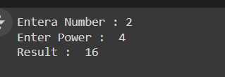

Part 2:

* If n ==0 no multiplication is performed T(0)=1
* Multiplication is performed in two cases:

If n is even while function call the problem is reduce to n/2 and multiplication is T(n)=T(n/2)+1.

If n is odd while function call the problem is reduce to (n-1)/2 and multiplied with T(n)=T(n-1)/2.

* Solving Recurrence Relation:

T(n)=T(n/2)+1 ---(i)

T(n/2)=T(n/4)+1 ----(ii)

T(n/4)=T(n/8)+1 ---(Iii)

Substituting eq (ii) in eq (i):

T(n)=T(n/4)+2 ---(iv)

Substituting eq (iiI) in eq (iv):

T(n)=T(n/8)+3

T(n)=T(n/2k)+k

Since k=log(n)

T(n)=log(n)

Part 3:

The Brute force approach for a^n would require n-1 multiplications as it directly multiply a by itself n-1 times. So Multiplications will be O(n) for brute force.

The divide and conquer method would require Multiplications O(log n) making it more efficient than brute force

C:

def inversions(Array):

  def Inv_counts(Array,temp_Array,low,mid,high):

    i=low

    j=mid+1

    k=low

    counts=0

    while i<=mid and j<=high:

      if Array[i]<= Array[j]:

        temp_Array[k]=Array[i]

        i+=1

      else:

        temp_Array[k]=Array[j]

        counts+=(mid-i+1)

        j+=1

      k+=1

    while i<=mid:

      temp_Array[k]=Array[i]

      i+=1

      k+=1

    while j<=high:

      temp_Array[k]=Array[j]

      j+=1

      k+=1

    for i in range(low,high+1):

      Array[i]=temp_Array[i]

    return counts

  def countMergeSort(Array,temp_Array,low,high):

    counts=0;

    if low>=high:

      return 0

    mid=(low+high)//2

    counts+=countMergeSort(Array,temp_Array,low,mid)

    counts+=countMergeSort(Array,temp_Array,mid+1,high)

    counts+=Inv_counts(Array,temp_Array,low,mid,high)

    return counts

  temp_Array=[0]*len(Array)

  return countMergeSort(Array,temp_Array,0,len(Array)-1)

n=int(input("Enter Number of Elements in an Array : "))

A=[]

for i in range (n):

  element=int(input(f"Number {i+1}: "))

  A.append(element)

print("Array: ",A)

inversions_count=inversions(A)

print("Number of inversions are : ",inversions_count)

Example Output:

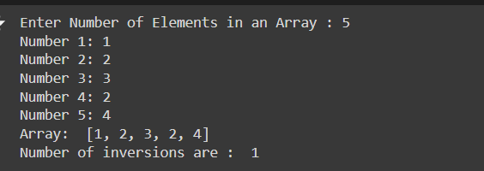

* Inv_counts functions counts inversions between the left and right halves of the array
* countMergeSort recursively divides the array into two halves ,counts inversions and then merges them.
* Time complexity O(nlogn) due to recursively splitting and merging steps.
* Brute force would have required O(n2) by comparing each pair (i,j) where i<j and counting inversions
* Divide and Conquer requires only O(nlogn) which is more efficient than brute force.

D:

1. Best Case Complexity:

This happens whenever the pivot selected splits the array in hales that are almost equal at every level of recursive process. In this case, the height of the recursion tree is logarithmic (approx. (log n) ,and each recursive level takes linear time to split the given array into partitions.

Best case will yield Complexity :)O(n log n).

For example:

Input Array:

8, 3, 7, 1, 9, 6, 2, 5, 48, 3, 7, 1, 9, 6, 2, 5, 48, 3, 7, 1, 9, 6, 2, 5, 4

1. Choose Pivot (5):  
   Partition: 3, 1, 2, 43, 1, 2, 43, 1, 2, 4 | 5 | 8, 7, 9, 68, 7, 9, 68, 7, 9, 6
2. Left Partition (3, 1, 2, 43, 1, 2, 43, 1, 2, 4):  
   Pivot (3): 1, 21, 21, 2 | 3 | 444
3. Right Partition (8, 7, 9, 68, 7, 9, 68, 7, 9, 6):  
   Pivot (8): 7, 67, 67, 6 | 8 | 999
4. Further Breakdown:
   * 1,21, 21,2 → Sorted as 1,21, 21,2
   * 7,67, 67,6 → Sorted as 6,76, 76,7
5. Combine Results:  
   Left: 1,2,3,41, 2, 3, 41,2,3,4, Pivot: 555, Right: 6,7,8,96, 7, 8, 96,7,8,9

Final Output:

1, 2, 3, 4, 5, 6, 7, 8, 91, 2, 3, 4, 5, 6, 7, 8, 91, 2, 3, 4, 5, 6, 7, 8, 9

1. Worst Case Complexity:

This happens when the pivot is always the smallest or largest element in the array .In these cases, one subarray will have n-1 elements while the other subarray has 0 elements. This leads to skew recursion tree. The height of recursion tree will be linear, equal to n and each level needs linear work to partition, and hence the total work done will be : n+(n-1)+(n-2)+….1=O(n2).

Worst case will yield Complexity : O(n2).

For example:

### Input Array:

9,8,7,6,5,4,3,2,19, 8, 7, 6, 5, 4, 3, 2, 19,8,7,6,5,4,3,2,1 (sorted in descending order)

1. **Choose Pivot (9):**  
   Partition: | 9 | 8,7,6,5,4,3,2,18, 7, 6, 5, 4, 3, 2, 18,7,6,5,4,3,2,1
2. **Right Partition (**8,7,6,5,4,3,2,18, 7, 6, 5, 4, 3, 2, 18,7,6,5,4,3,2,1**):**  
   Pivot (8): | 8 | 7,6,5,4,3,2,17, 6, 5, 4, 3, 2, 17,6,5,4,3,2,1
3. **Next Right Partition (**7,6,5,4,3,2,17, 6, 5, 4, 3, 2, 17,6,5,4,3,2,1**):**  
   Pivot (7): | 7 | 6,5,4,3,2,16, 5, 4, 3, 2, 16,5,4,3,2,1
4. **Continue Similarly:**  
   Each step selects the largest element as the pivot, leaving the rest of the array in the right partition.
   * Pivot (6): | 6 | 5,4,3,2,15, 4, 3, 2, 15,4,3,2,1
   * Pivot (5): | 5 | 4,3,2,14, 3, 2, 14,3,2,1
   * Pivot (4): | 4 | 3,2,13, 2, 13,2,1
   * Pivot (3): | 3 | 2,12, 12,1
   * Pivot (2): | 2 | 111
   * Pivot (1): | 1 |

### Final Output:

1, 2, 3, 4, 5, 6, 7, 8, 91, 2, 3, 4, 5, 6, 7, 8, 91, 2, 3, 4, 5, 6, 7, 8, 9

E:

Part 1:

def closest_pair(Array):

  #Sorting array in nlogn

  Array.sort()

  def closest_inarray(Array):

    min_diff=float('inf')

    Pair=(None,None)

    for i in range(len(Array)-1):

      difference=Array[i+1]-Array[i]

      if(difference<min_diff):

        min_diff=difference

        Pair=(Array[i],Array[i+1])

    return Pair,min_diff

  closestPair,min_difference=closest_inarray(Array)

  return closestPair,min_difference

a=int(input("Enter Number of Elements in an Array : "))

A=[]

for i in range (a):

  element=int(input(f"Number {i+1}: "))

  A.append(element)

print("Array: ",A)

closestPair,min_difference=closest_pair(A)

print("Closest Pair is : ",closestPair)

print("Minimum Difference is : ",min_difference)

Example Output:

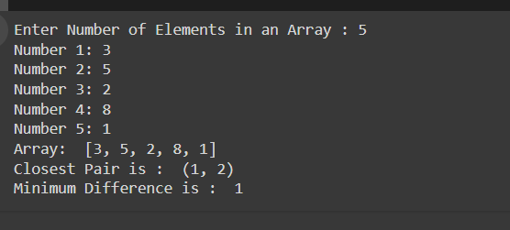

Part 2:

Yes, this is an efficient algorithm for the one-dimensional closest-pair problem:

* Optimal Efficiency: In one-dimensional case: O(n log n) because the problem naturally include a basic operation that yields finding the closest pair.
* Simplicity and Directness : The problem then merely reduces to a simple scan of the consecutive elements, so the solution is elegant and simple

In conclusion, divide and conquer based algorithm is efficient and well suited.

F:

def FindPeak(Array,high,low):

  if(high==low):

      return low

  mid=(low+high)//2

  if(Array[mid]>Array[mid+1] and Array[mid]>Array[mid-1]):

      return mid,Array[mid]

  elif(Array[mid]<Array[mid+1]):

      return FindPeak(Array,high,mid+1)

  else:

      return FindPeak(Array,mid-1,low)

#input number of elements in an array

n=int(input("Enter Number of Elements in an Array : "))

A=[]

for i in range (n):

  element=int(input(f"Number {i+1}: "))

  A.append(element)

print("Array: ",A)

Peak_index,Peak=FindPeak(A,len(A)-1,0)

print(f"Peak Point is :{Peak} at index: {Peak_index}")

Example Output:

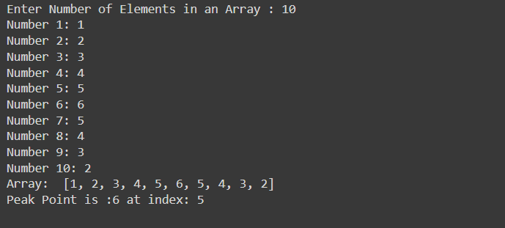

Time Complexity: O(logn)

As we have solved the problem by breaking Array into two halves like binary search and recursively have solved the problem to achieve time complexity O(logn)

The recurrence relation is:

T(n) <= T(n/2)+c

When n>2,

T(2) <=c

In this problem we divided the Array into two halves and Peak point is where:

(Array[mid]>Array[mid+1] and Array[mid]>Array[mid-1])

If (Array[mid]<Array[mid+1]) then we have checked the left part of the Array

Else the peak point will lie in right part of the array

For example: {1,2,3,4,5,4,2}

1. First call:

Mid=3, value=4,not peak. Move Right

1. Second call:

Mid=5 ,value =4 , not peak. Move left

1. Third call:

Mid=4, value=5 , which is peak point

G:

def Max_profit(price,low,high,bday,sday,profit):

  if(high==low):

    bday=sday=low

    profit=0

    return(0,low,high)# No profit

  mid=(low+high)//2

  #recursive call to fing max profit in left and right halves of the array

  l_prof,l_buy,l_sell=Max_profit(price,low,mid,bday,sday,profit) # checking in left Half

  r_prof,r_buy,r_sell=Max_profit(price,mid+1,high,bday,sday,profit)# Checking in right half

  # Min price in left half:

  min_lprice=min(price[low:mid+1])

  # MIn price in right half

  max_rprice=max(price[mid+1:high+1])

  check_profit=max_rprice-min_lprice

  if(l_prof>=r_prof and l_prof>= check_profit):

    bday=l_buy

    sday=l_sell

    profit=l_prof

    return(profit,bday,sday)

  elif(r_prof>=l_prof and r_prof>=check_profit):

    bday=r_buy

    sday=r_sell

    profit=r_prof

    return(profit,bday,sday)

  else:

    bday=price.index(min_lprice,low,mid+1)

    sday=price.index(max_rprice,mid+1,high+1)

    return(check_profit,bday,sday)

n=int(input("Enter Number of Days : "))

price=[]

for i in range (n):

  element=float(input(f"Number {i+1}: "))

  price.append(element)

profit,buyday,sellday=Max_profit(price,0,len(price)-1,0,0,0)

print(f"Buy Day {buyday+1}, Sel day {sellday+1}, Profit : {profit}")

Example Output:

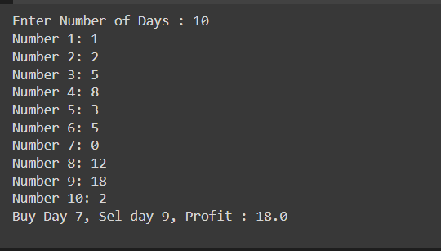

H:

Part 2:

def inversions(Array):

  def SigInv_counts(Array,temp_Array,low,mid,high):

    counts=0

    for i in range (low,mid+1):

      j=mid+1

      while j<=high and Array[i]>2*Array[j]:

        j+=1

      counts+=(j-(mid+1))

    k=low

    j=mid+1

    i=low

    while i<=mid and j<=high:

      if Array[i]<= Array[j]:

        temp_Array[k]=Array[i]

        i+=1

      else:

        temp_Array[k]=Array[j]

        j+=1

      k+=1

    while i<=mid:

      temp_Array[k]=Array[i]

      i+=1

      k+=1

    while j<=high:

      temp_Array[k]=Array[j]

      j+=1

      k+=1

    for i in range(low,high+1):

      Array[i]=temp_Array[i]

    return counts

  def countMergeSort(Array,temp_Array,low,high):

    counts=0

    if low>=high:

      return 0

    mid=(low+high)//2

    counts+=countMergeSort(Array,temp_Array,low,mid)

    counts+=countMergeSort(Array,temp_Array,mid+1,high)

    counts+=SigInv_counts(Array,temp_Array,low,mid,high)

    return counts

  temp_Array=[0]*len(Array)

  return countMergeSort(Array,temp_Array,0,len(Array)-1)

n=int(input("Enter Number of Elements in an Array : "))

A=[]

for i in range (n):

  element=int(input(f"Number {i+1}: "))

  A.append(element)

print("Array: ",A)

inversions_count=inversions(A)

print("Number of Significant inversions are : ",inversions_count)

Example Output:

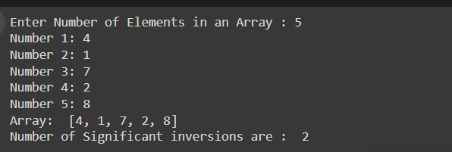

Part 5:

class Line:

  def __init__(self, a, b):

    self.a = a

    self.b = b

  def y(self, x):

    return self.a * x + self.b

class Event:

  def __init__(self, x, line, event_type):

    self.x = x

    self.line = line

    self.type = event_type

class HiddenSurfaceRemoval:

  @staticmethod

  def find_visible_lines(lines):

    events = []

    for line in lines:

      events.append(Event(float('-inf'), line, 1))

      events.append(Event(float('inf'), line, -1))

    events.sort(key = lambda e: e.x)

    active_lines = []

    visible_lines = []

    for event in events:

      if event.type == 1:

        active_lines.append(event.line)

        if HiddenSurfaceRemoval.is_topmost(active_lines,event.line, event.x):

          visible_lines.append(event.line)

      else:

        active_lines.remove(event.line)

        if active_lines and HiddenSurfaceRemoval.is_topmost(active_lines, active_lines[-1], event.x):

          visible_lines.append(active_lines[-1])

    return visible_lines

  @staticmethod

  def is_topmost(lines, line, x):

    for other_line in lines:

      if other_line != line and other_line.y(x) > line.y(x):

        return False

    return True

if __name__ == "__main__":

  lines = [

      Line(1, 2),

      Line(-2, 4),

      Line(0.5, -1),

      Line(3, 0),

      Line(-1, 1)

  ]

  visible_lines = HiddenSurfaceRemoval.find_visible_lines(lines)

  print("Visible lines: y = ax + b")

  for line in visible_lines:

    print(f"{line.a}x + {line.b}")

Example Out[ut:

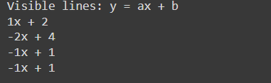

Part 3:

from collections import defaultdict

class BankCard:

  def __init__(self, account_holder_name, account_number):

    self.account_holder_name = account_holder_name

    self.account_number = account_number

  def get_account_holder_name(self):

    return self.account_holder_name

  def get_acount_number(self):

    return self.account_number

  def __eq__(self, other):

    if not isinstance(other, BankCard):

      return False

    return self.account_number == other.account_number

  def __hash__(self):

    return hash(self.account_number)

class EquivalenceTestor:

  def are_equivalent(self, card1, card2):

    return card2 == card2

class FraudDetection:

  @staticmethod

  def find_majority_equivalent(cards):

    if not cards:

      return False

      tester = EquivalenceTester()

      candidate = None

      count = 0

      for card in cards:

        if count == 0:

          candidate = card

          count = 1

        else:

          if tester.are_equivalent(card, candidate):

            count += 1

          else:

            count -= 1

      count = 0

      for card in cards:

        if tester.are_equivalent(card, candidate):

          count += 1

      return count > len(cards) / 2

if __name__ == "__main__":

  cards = []

  cards.append(BankCard("WaniyaBadar", "12345"))

  cards.append(BankCard("AlishbaHassan", "98765"))

  cards.append(BankCard("WaniyaBadar", "12345"))

  cards.append(BankCard("WaniyaBadar", "12345"))

  cards.append(BankCard("Nimil", "09007"))

  result = FraudDetection.find_majority_equivalent(cards)

  print("Is majority equivalent set? ", result)

Example Output:

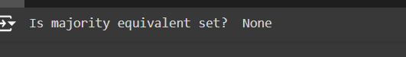

Question no:2 and 3

import math

import random

import os

def euclidean_distance(p1,p2):

  return math.sqrt((p1[0]-p2[0])**2+(p1[1]-p2[1])**2)

def closest_in_strip(strip,min_distance):

  min_pair=None

  strip.sort(key=lambda x:x[1])

  for i in range(len(strip)):

    for j in range(i+1,len(strip)):

      if(strip[j][1]-strip[i][1]<min_distance):

        distance=euclidean_distance(strip[i],strip[j])

        if(distance<min_distance):

          min_distance=distance

          min_pair=(strip[i],strip[j])

  return min_distance,min_pair

def closest_pair_recursive(points_sorted_x):

  if len(points_sorted_x)<=3:

    return closest_in_strip(points_sorted_x,float("inf"))

  mid=len(points_sorted_x)//2

  left_points=points_sorted_x[:mid]

  right_points=points_sorted_x[mid:]

  left_min_distance, left_pair=closest_pair_recursive(left_points)

  right_min_distance,right_pair=closest_pair_recursive(right_points)

  min_distance=min(left_min_distance,right_min_distance)

  min_pair=left_pair if left_min_distance<right_min_distance else right_pair

  mid_x=points_sorted_x[mid][0]

  strip=[point for point in points_sorted_x if abs(point[0]-mid_x)<min_distance]

  strip_distance,strip_pair=closest_in_strip(strip,min_distance)

  if strip_distance<min_distance:

    return strip_distance,strip_pair

  return min_distance,min_pair

def closest_pair(points):

  if len(points)< 2:

    return None, None

  points_sorted_x=sorted(points,key=lambda x:x[0])

  return closest_pair_recursive(points_sorted_x)

def generate_random_points(num_points=100):

  return[(random.randint(0,1000),random.randint(0,1000)) for _ in range(num_points)]

def save_points_to_file(points,filename):

  with open(filename,'w') as file:

    for point in points:

      file.write(f"{point[0]} {point[1]}\n")

if __name__=="__main__":

  os.makedirs("closest_pair_samples",exist_ok=True)

  for i in range(1,11):

    points=generate_random_points()

    save_points_to_file(points,f"closest_pair_samples/sample_{i}.txt")

    min_distance,closest_points=closest_pair(points)

    print(f'Sample {i} generated and saved . Closest pair is : {closest_points} with distance {min_distance}')

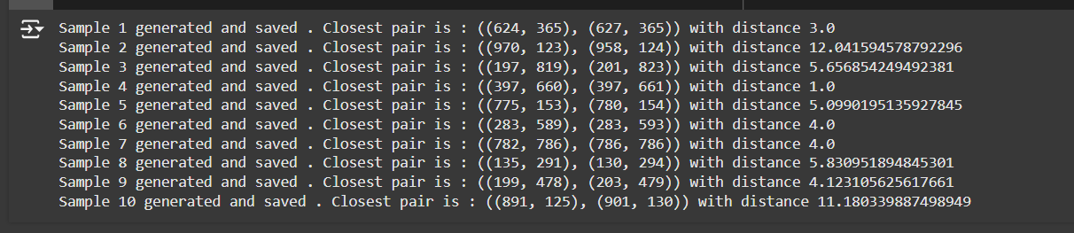

Integer Multiplication:

import random

import os

def karatsuba(x,y):

  if x<10 or y<10:

    return x*y

  n=max(len(str(x)),len(str(y)))

  m=n//2

  high1,low1=divmod(x,10**m)

  high2,low2=divmod(y,10**m)

  z0=karatsuba(low1,low2)

  z1=karatsuba((low1+high1),(low2+high2))

  z2=karatsuba(high1,high2)

  return z2*(10**(2*m))+(z1-z2-z0)*(10**m)+z0

def generate_large_numbers(num_samples,digit_length):

    samples=[]

    for _ in range(num_samples):

      x=random.randint(10**(digit_length-1),10**digit_length-1)

      y=random.randint(10**(digit_length-1),10**digit_length-1)

      samples.append((x,y))

    return samples

def save_samples(samples,base_path="integer_multiplication_samples"):

    os.makedirs(base_path,exist_ok=True)

    for i,(x,y) in enumerate(samples):

      filename=os.path.join(base_path,f"sample_{i+1}.txt")

      with open(filename,'w') as file:

         file.write(f"{x}\n{y}")

if __name__=="__main__":

   num_samples=10

   digit_length=100

   samples=generate_large_numbers(num_samples,digit_length)

   save_samples(samples)

   for i,(x,y) in enumerate(samples):

     result=karatsuba(x,y)

     print(f"Sample {i+1} Result: {result}")

output:

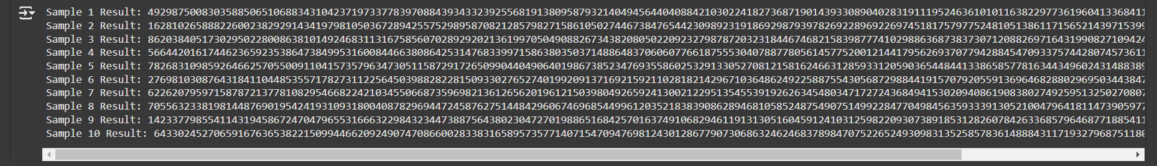

Question no:4

import tkinter as tk

from tkinter import filedialog

import math

import matplotlib.pyplot as plt

from matplotlib.backends.backend_tkagg import FigureCanvasTkAgg

# Karatsuba implementation with an improved tree-like visualization

def karatsuba(x, y, depth=0):

    if x < 10 or y < 10:

        return x * y

    n = max(len(str(x)), len(str(y)))

    m = n // 2

    high1, low1 = divmod(x, 10**m)

    high2, low2 = divmod(y, 10**m)

    # Recursively calculate the three products

    z0 = karatsuba(low1, low2, depth + 1)

    z1 = karatsuba((low1 + high1), (low2 + high2), depth + 1)

    z2 = karatsuba(high1, high2, depth + 1)

    # Improved visualization of recursive steps (text representation)

    tree_text.insert(tk.END, f"{'  ' * depth}Depth {depth}: z2={z2}, z1={z1}, z0={z0}\n")

    tree_text.see(tk.END)

    # Return the result with the corrected formula

    return z2 * (10**(2 * m)) + (z1 - z2 - z0) * (10**m) + z0

# Euclidean distance for Closest Pair

def euclidean_distance(p1, p2):

    return math.sqrt((p1[0] - p2[0])**2 + (p1[1] - p2[1])**2)

# Closest Pair with scatter plot and highlighted pair

def closest_pair(points):

    min_dist = float('inf')

    pair = None

    fig, ax = plt.subplots()

    # Scatter plot of points

    x_vals, y_vals = zip(*points)

    ax.scatter(x_vals, y_vals, color='blue', label="Points")

    # Find the closest pair

    for i in range(len(points)):

        for j in range(i + 1, len(points)):

            dist = euclidean_distance(points[i], points[j])

            if dist < min_dist:

                min_dist = dist

                pair = (points[i], points[j])

    # Draw a line and circle between the closest pair

    if pair:

        ax.plot(

            [pair[0][0], pair[1][0]],

            [pair[0][1], pair[1][1]],

            color='red',

            linestyle='--',

            linewidth=2,

            label="Closest Pair"

        )

        # Highlight the closest pair points

        ax.scatter(pair[0][0], pair[0][1], color='green', s=100, edgecolor='black', label="Closest Point 1", zorder=5)

        ax.scatter(pair[1][0], pair[1][1], color='green', s=100, edgecolor='black', label="Closest Point 2", zorder=5)

    ax.set_title("Closest Pair Visualization")

    ax.legend()

    # Embed the plot in the Tkinter window

    canvas = FigureCanvasTkAgg(fig, master=result_frame)

    canvas.draw()

    canvas.get_tk_widget().pack()

    return min_dist, pair

# File processing function

def process_file():

    global tree_text

    file_path = filedialog.askopenfilename(filetypes=[("Text files", "*.txt")])

    if not file_path:

        return

    with open(file_path, 'r') as file:

        content = file.read().strip()

        lines = content.split('\n')

    # Clear previous content in the result frame

    for widget in result_frame.winfo_children():

        widget.destroy()

    if len(lines) == 2:  # Integer multiplication case

        x, y = map(int, lines)

        # Create Karatsuba frame

        karatsuba_frame = tk.Frame(result_frame, bg="#E5E5E5", bd=2, relief="groove", padx=20, pady=20)

        karatsuba_frame.pack(padx=20, pady=10, fill="both", expand=True)

        # Create the tree_text widget for Karatsuba

        tree_text = tk.Text(karatsuba_frame, bg="#E5E5E5", fg="#000000", font=("Courier New", 12), wrap="word", height=10)

        tree_text.pack()

        result = karatsuba(x, y)

        # Add Karatsuba result - center-aligned and wrapped

        karatsuba_result_label = tk.Label(

            karatsuba_frame,

            text=f"Karatsuba Multiplication Result: {result}",

            bg="#E5E5E5",

            fg="#000000",

            font=("Courier New", 14, "bold"),

            pady=10,

            wraplength=650,  # Wrap long lines

            justify="center"  # Center the text

        )

        karatsuba_result_label.pack()

    else:  # Closest pair case

        points = [tuple(map(int, line.split())) for line in lines]

        # Create Closest Pair frame

        closest_pair_frame = tk.Frame(result_frame, bg="#E5E5E5", bd=2, relief="groove", padx=20, pady=20)

        closest_pair_frame.pack(padx=20, pady=10, fill="both", expand=True)

        min_distance, closest_points = closest_pair(points)

        # Add Closest Pair result

        closest_pair_result_label = tk.Label(closest_pair_frame,

                                             text=f"Closest Pair: {closest_points}, Distance: {min_distance:.2f}",

                                             bg="#E5E5E5", fg="#000000", font=("Courier New", 14, "bold"), pady=10)

        closest_pair_result_label.pack()

    result_label.config(text="Processing Complete. Results displayed in the respective sections.")

# Tkinter GUI setup

root = tk.Tk()

root.title("Algorithm Runner with Visualization")

root.geometry("800x800")

root.configure(bg="#14213D")

# Header

header_label = tk.Label(root, text="Algorithm Runner", bg="#FCA311", fg="#000000", font=("Verdana", 28, "bold"))

header_label.pack(fill="x", pady=(0, 20))

# Instructions

instruction_frame = tk.Frame(root, bg="#E5E5E5")

instruction_frame.pack(padx=20, pady=10, anchor="center", fill="x")

instruction_label = tk.Label(instruction_frame, text="Upload a text file to process:", bg="#E5E5E5", fg="#000000", font=("Lucida Sans", 14, "bold"))

instruction_label.pack()

# Upload Button

upload_button = tk.Button(root, text="Upload and Process File", command=process_file, bg="#FCA311", fg="#000000", font=("Calibri", 16, "bold"), padx=20, pady=10, bd=0, relief="flat", cursor="hand2")

upload_button.pack(pady=20)

# Result Frame

result_frame = tk.Frame(root, bg="#E5E5E5", bd=2, relief="groove", padx=20, pady=20)

result_frame.pack(padx=20, pady=20, fill="both", expand=True)

# Result Label

result_label = tk.Label(result_frame, text="Awaiting file upload...", bg="#E5E5E5", fg="#000000", font=("Courier New", 16, "normal"), wraplength=650, justify="center")

result_label.pack()

root.mainloop()

